**Basic Data Structure Assignment**

[Q1](https://adapt.in.capgemini.com/mod/vpl/view.php?id=2148): Find out if the given number is an Armstrong number or not.

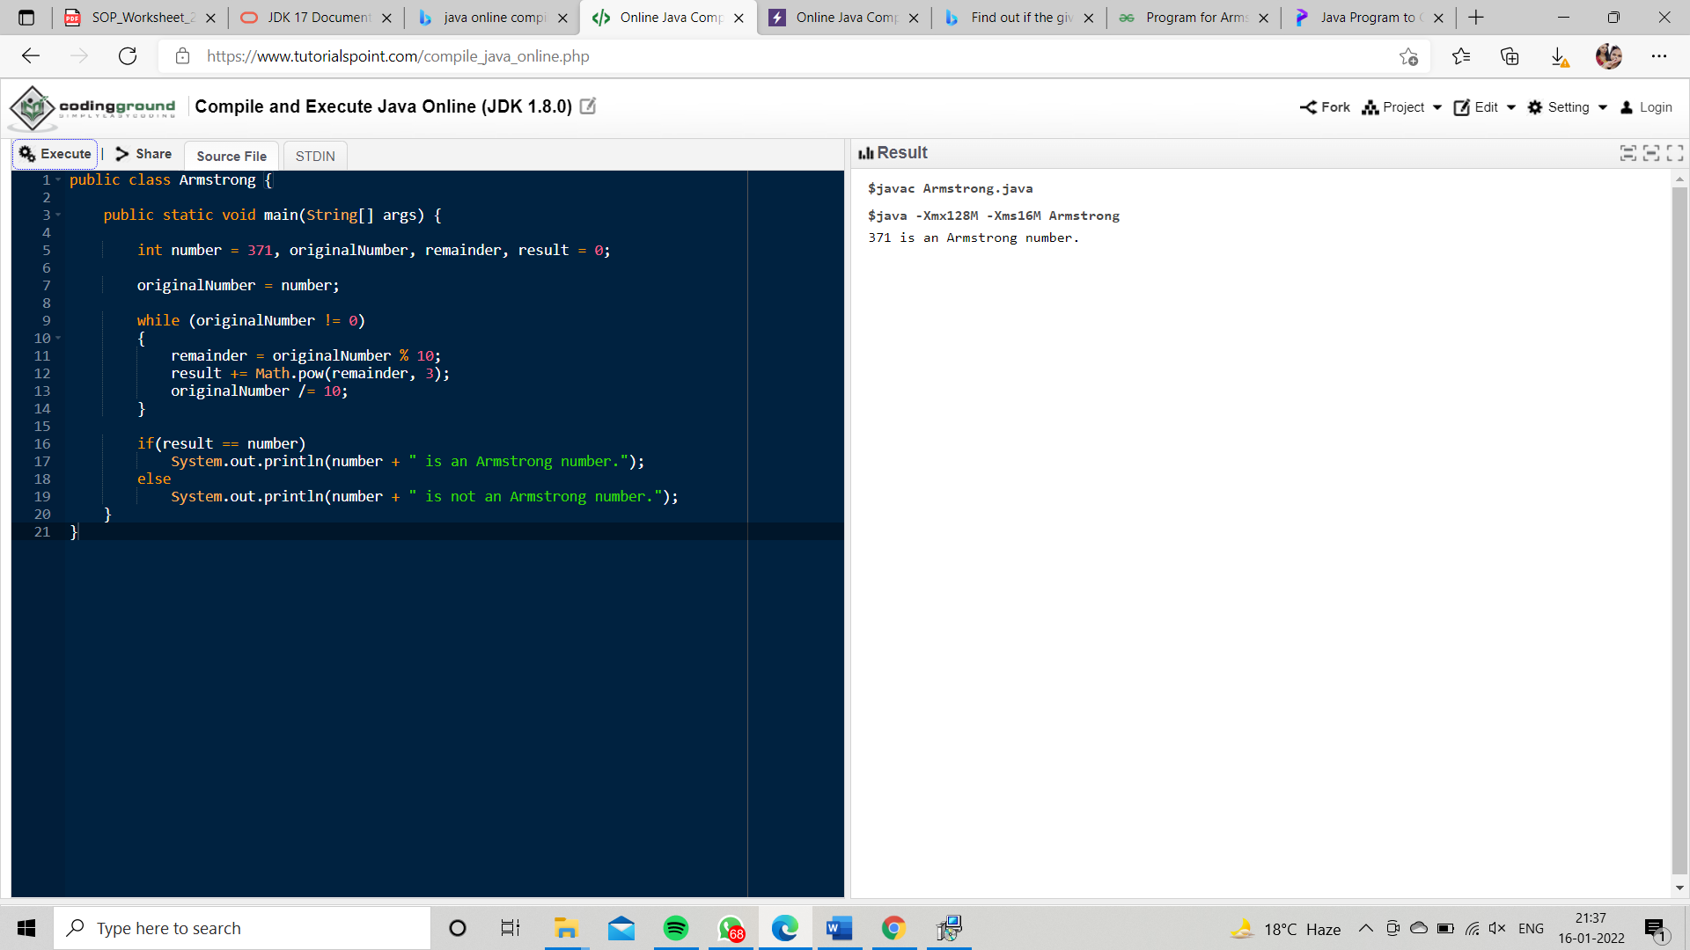

[Q2](https://adapt.in.capgemini.com/mod/vpl/view.php?id=2156). Find out all the Armstrong numbers falling in the range of 100-999

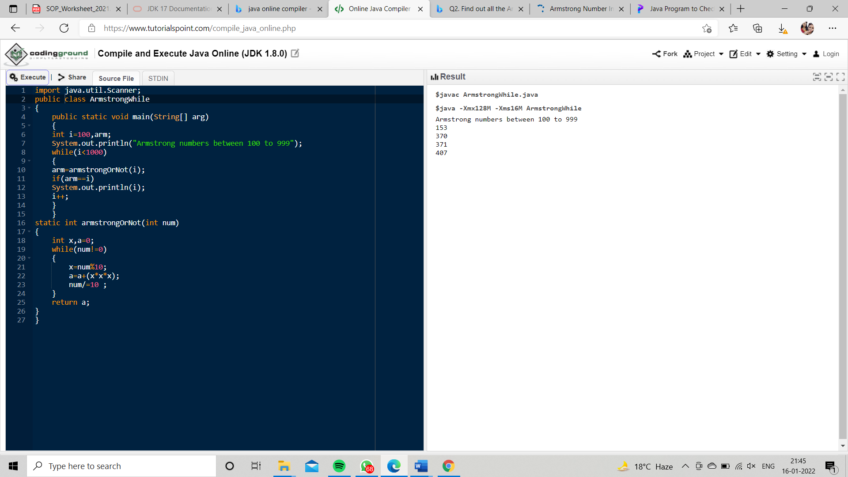

Q3. Find out the simple as well as the compound interest of supplied value

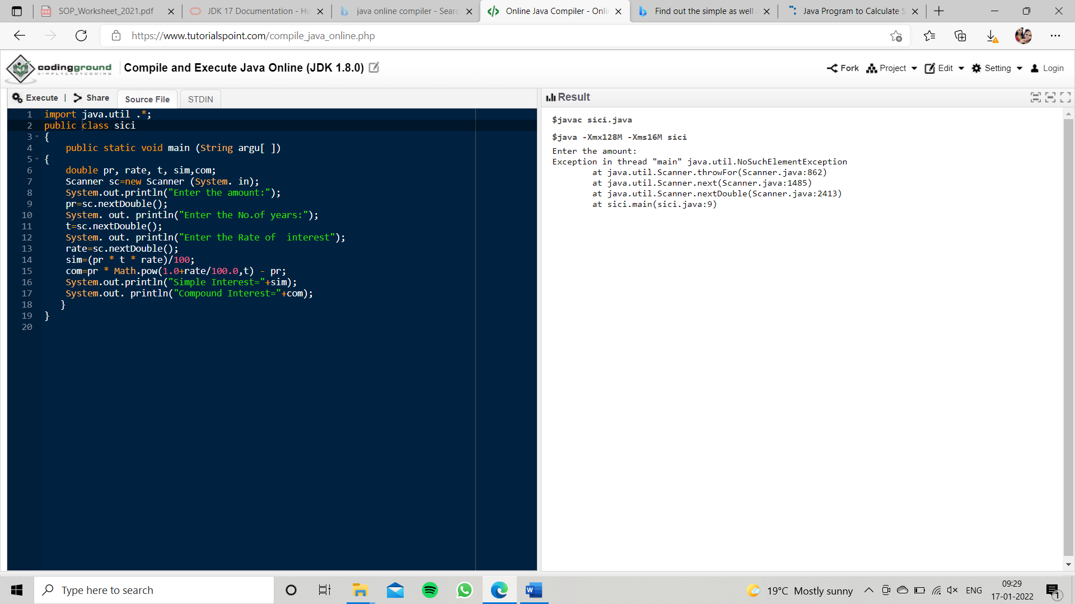

Q4.Supply marks of three subject and declare the result, result declaration is based on below conditions:

              Condition 1: -All subjects marks is greater than 60 is Passed

              Condition 2: -Any two subjects marks are greater than 60 is Promoted

              Condition 3: -Any one subject mark is greater than 60 or all subjects’ marks less than 60 is failed.

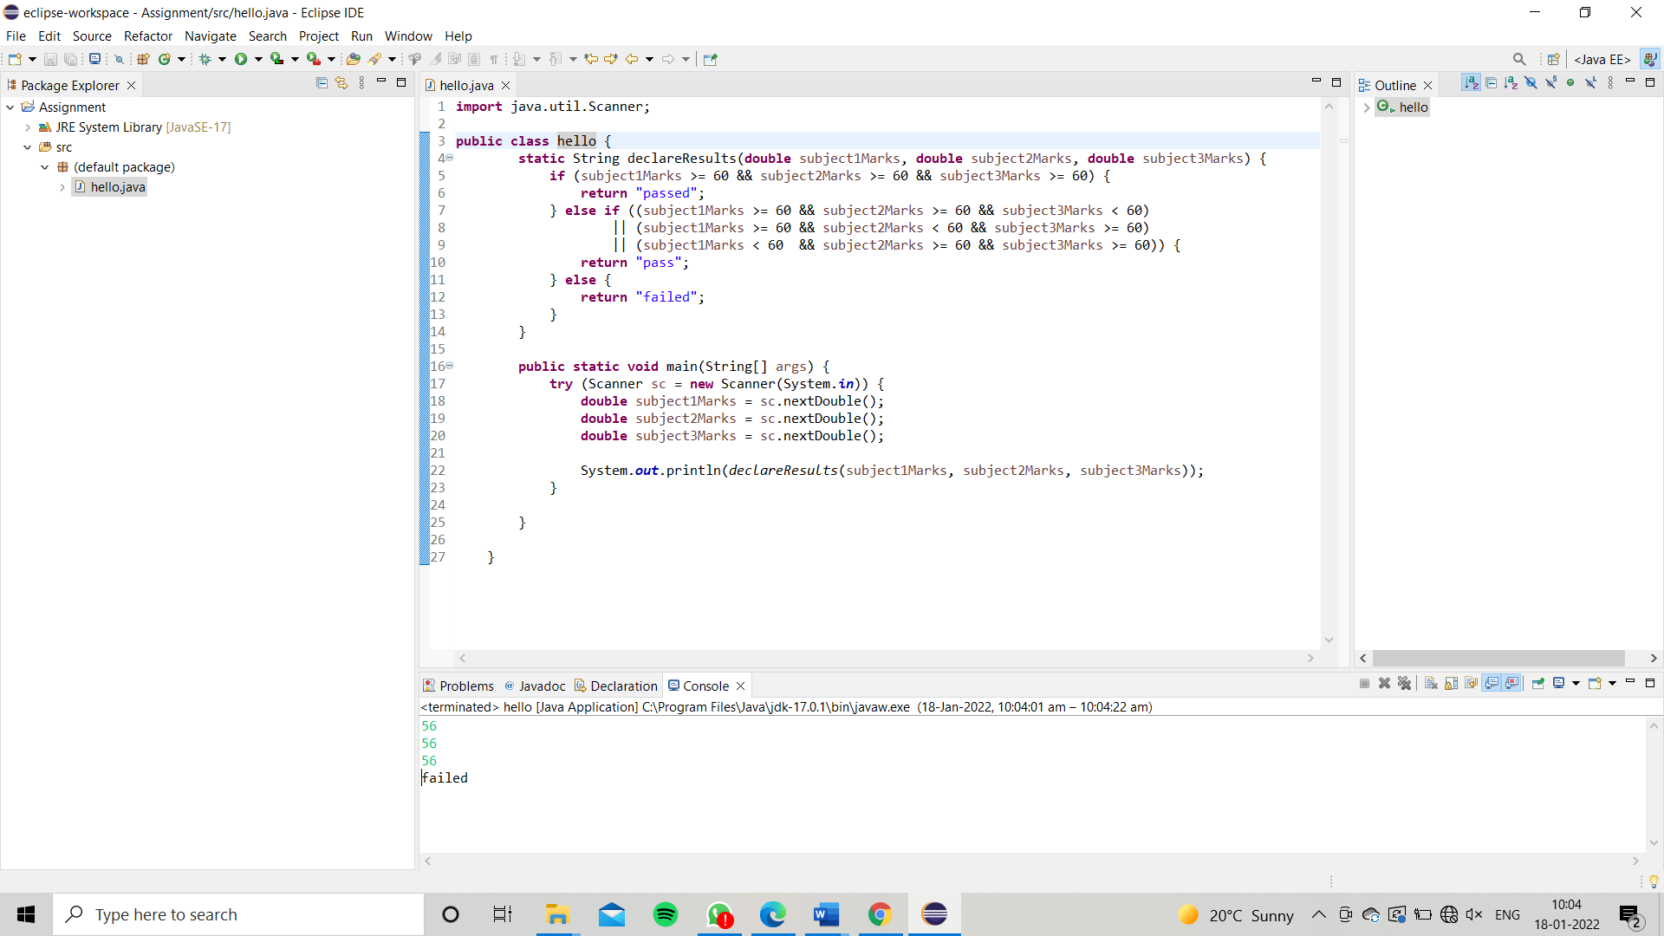

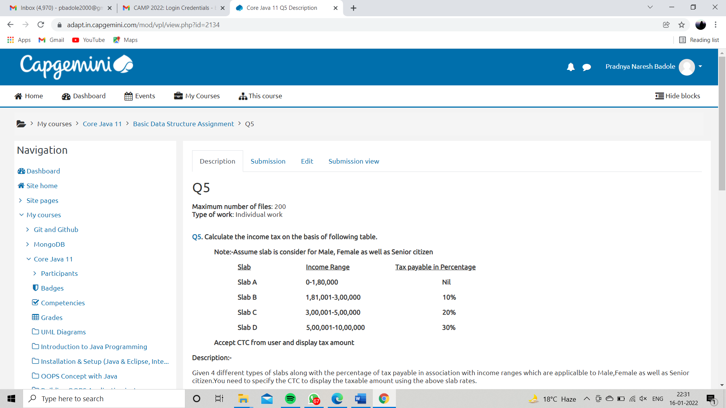

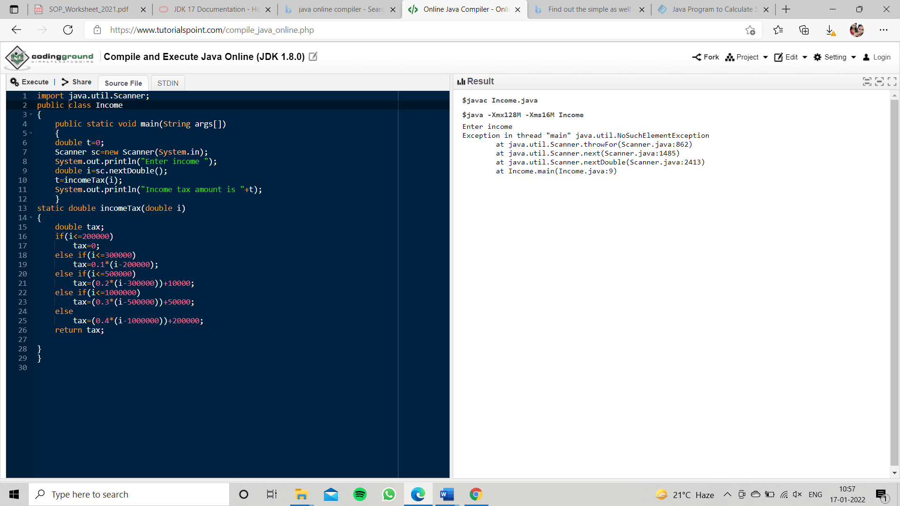

Q6

Maximum number of files: 200  
Type of work: Individual work

[Q6](https://adapt.in.capgemini.com/mod/vpl/view.php?id=2170). Consider a CUI based application, where you are asking a user to enter his Login name and password, after entering the valid user-id and password it will print the message “Welcome” along with user name. As per the validation is concerned, the program should keep a track of login attempts. After three attempts a message should be flashed saying “Contact Admin” and the program should terminate.

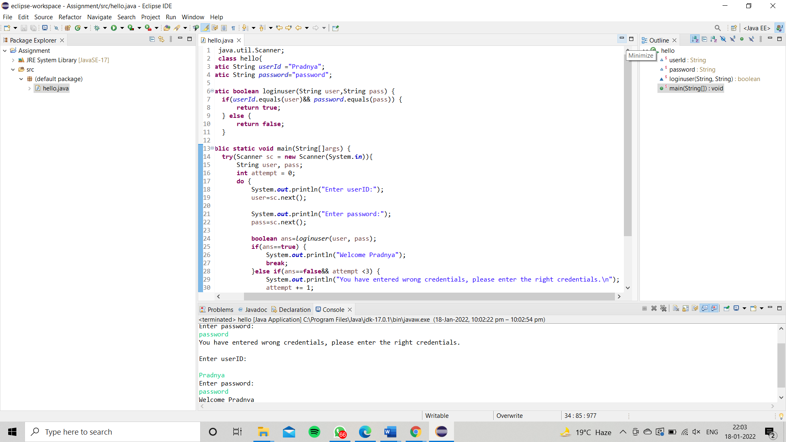

Q7 Maximum number of files: 200  
Type of work: Individual work

[Q7](https://adapt.in.capgemini.com/mod/vpl/view.php?id=2169). There is an Array which is of the size 15, which may or may not be sorted. You should write a program to accept a number and search if it in contained in the array

Example:

5 12 14 6 78 19 1 23 26 35 37 7 52 86 47

Value to be search is 19

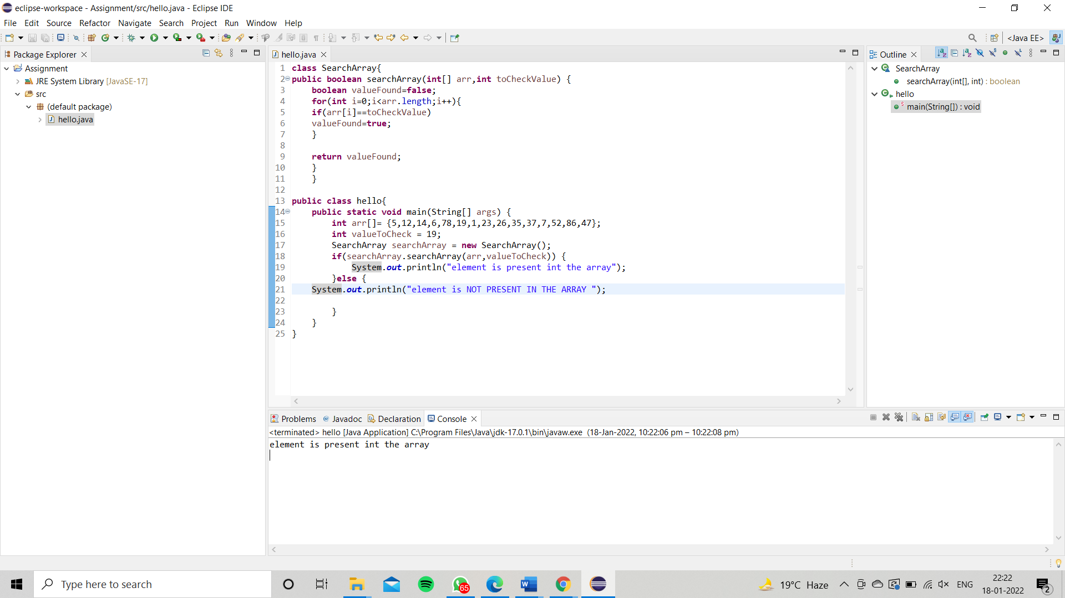

Q8 Maximum number of files: 200  
Type of work: Individual work

[Q8](https://adapt.in.capgemini.com/mod/vpl/view.php?id=2168). Using the below table write method apply sorting using Bubble Sort.

              Example:

              5 12 14 6 78 19 1 23 26 35 37 7 52 86 47

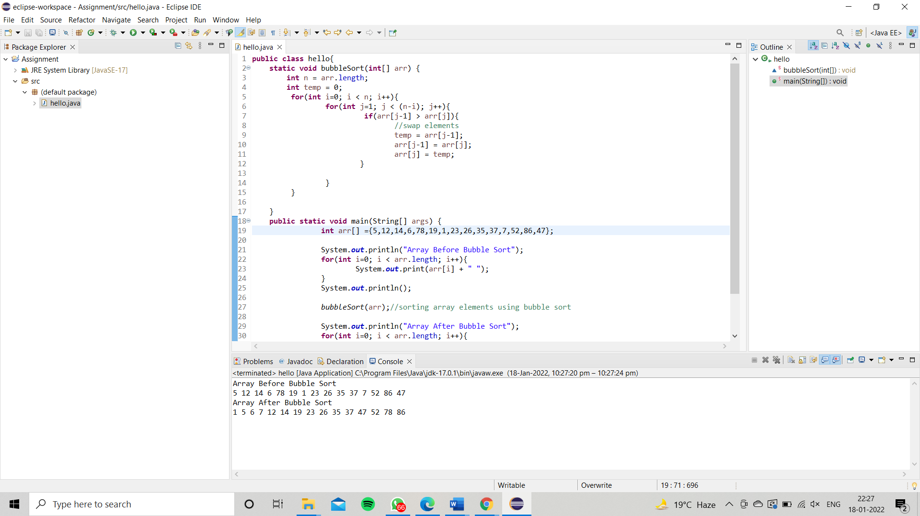

Q9. Maximum number of files: 200  
Type of work: Individual work

[Q9](https://adapt.in.capgemini.com/mod/vpl/view.php?id=2159). Accept the marks of three students for the subject say A, B, C. Find the total scored and the average in all the subjects. Also Find the Total and Average scored by students in each respective Subject**.**

